INF407: Modern Issues in Databases
Assignment 5B – Backup & Recovery
Niharika Jakkula

The following screenshots show the Advanced Options, successful export, and successful recovery process.
Advanced options screen shot
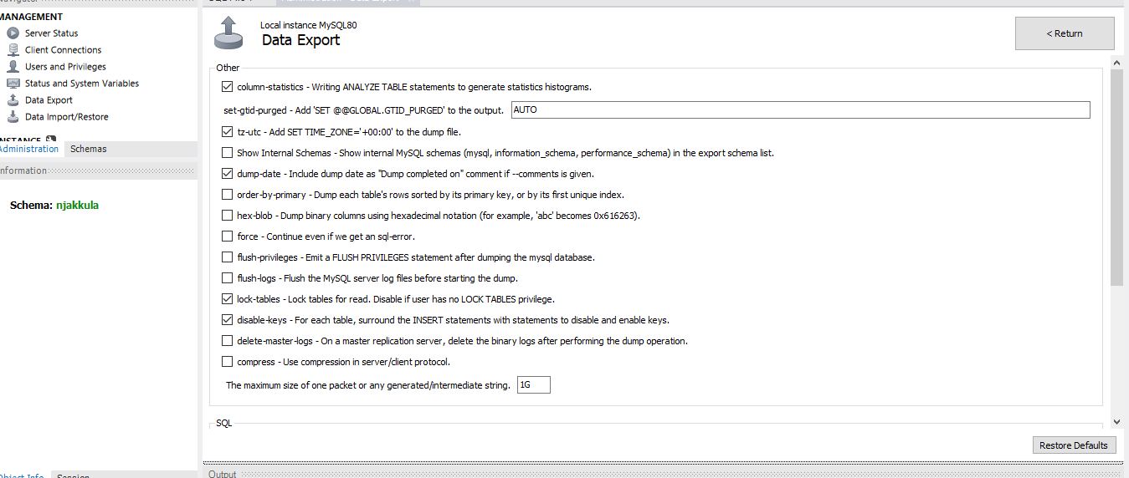

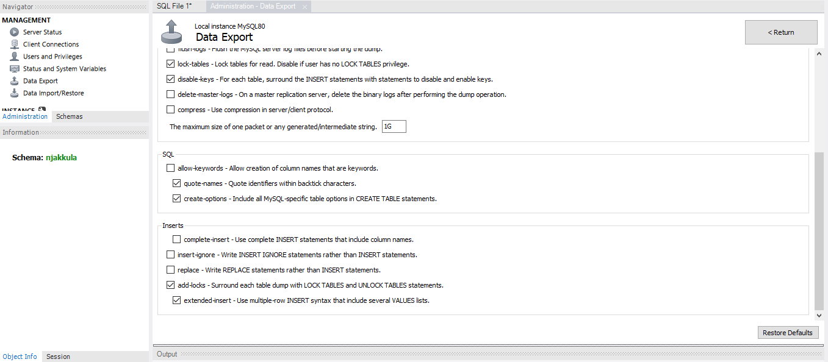
Data Exported successfully screen shot
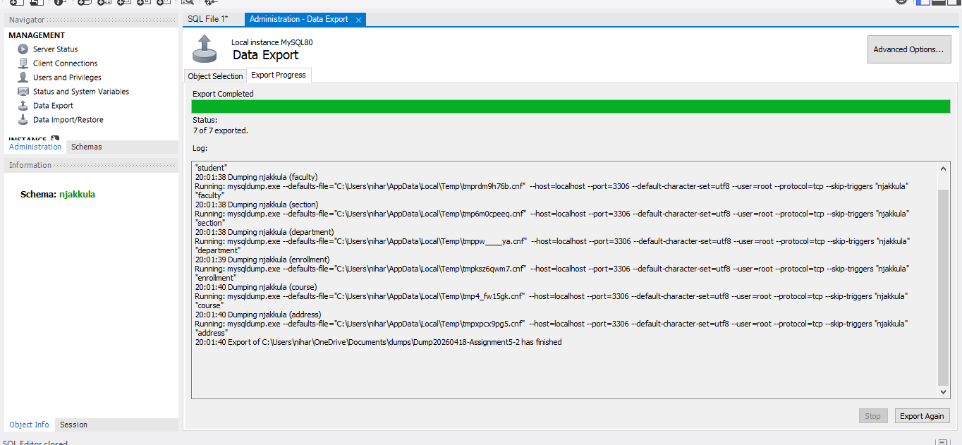
Data Imported successfully
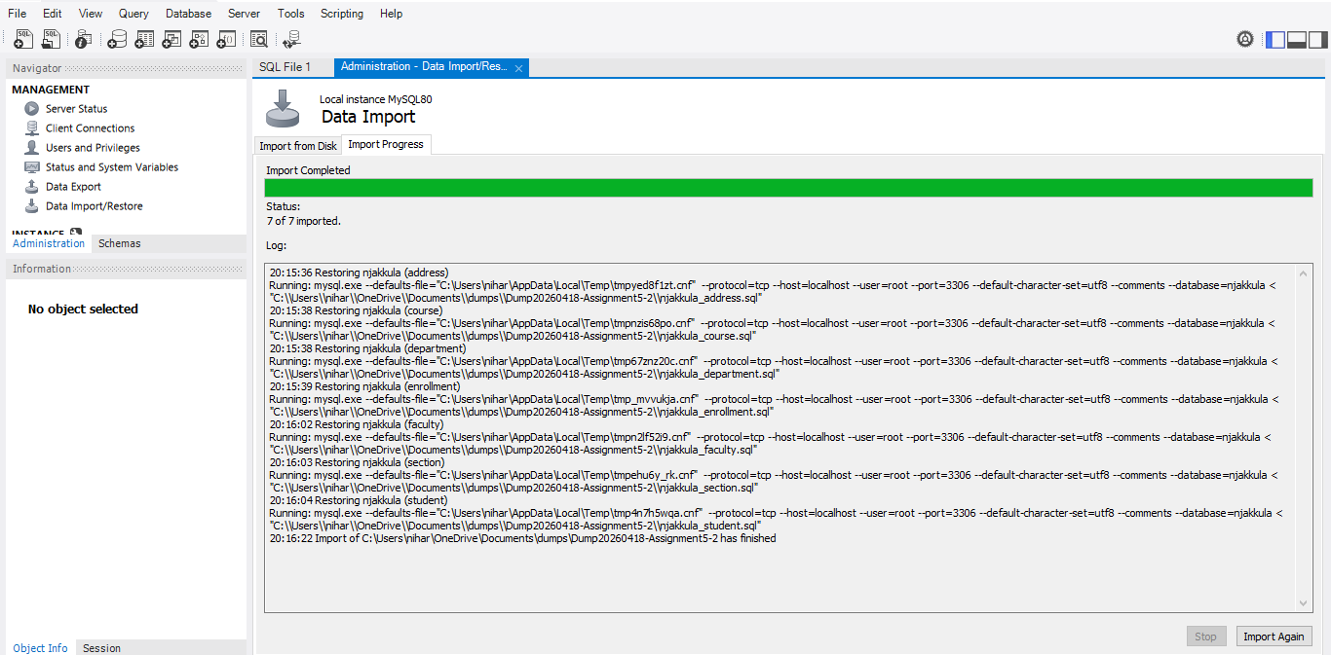
Part C Evaluation
For this assignment, I reviewed the Advanced Options available during the MySQL backup process and completed a successful backup recovery. Based on the lecture materials, disaster recovery planning depends on having reliable backups, restoration procedures, and validation steps to confirm the data was recovered correctly . In my database environment, I believe the default settings under Advanced Options provide the best starting point because they are already configured for common backup needs and help create a dependable backup file. For a small academic database, default settings are efficient, simple to use, and reduce the chance of user error. However, customized settings may be useful depending on storage space, performance needs, or how quickly recovery must happen.
One important customization is compression. Compression reduces the size of the backup file, which is useful when storing many backups or transferring backups to another location. Smaller files can save disk space and improve backup management. The disadvantage is that compression uses additional CPU resources and may slightly slow both the export and import process because the file must be compressed and later decompressed. In my environment, compression was not necessary because the database size was manageable, but it would be beneficial for larger business systems with frequent backups.
Another major setting is the use of locks. In my default configuration, lock-tables was enabled. Locks are helpful because they prevent tables from being modified during the backup process. This improves consistency and helps ensure the backup contains accurate data. If records were changing while the backup was running, the file could contain incomplete or mismatched information. The disadvantage is that locks may temporarily prevent users from inserting or updating data. In a busy production database this could interrupt operations, but in my student environment this was acceptable because data consistency was more important.
The force option allows the backup process to continue even if an SQL error occurs. The advantage of this setting is that one damaged table or minor issue does not stop the entire backup. This can be valuable during emergency situations where recovering most of the database is better than having no backup at all. The disadvantage is that errors may be skipped, which can lead to an incomplete backup file. For that reason, I would use force carefully and only when necessary.
The order by primary key option exports rows sorted by their primary key values. This can make the backup file more organized, easier to review, and may improve consistency during recovery. However, sorting rows adds additional processing time during the export. For small databases this delay is minor, but for very large databases it could noticeably slow the backup process.
Overall, I believe the default settings are best for routine backups because they balance consistency, speed, and ease of use. Custom settings such as compression, force, and order by primary key should be chosen based on the size of the database and business recovery needs. After recovery, I validated my backup by confirming all seven tables were restored and verifying row counts through SQL queries, which aligns with the validation practices discussed in the lecture materials.

